**Year 5 – Home Learning Challenge 8**

**Daily activities**

* **Reading** Log onto your active learn and discover the many books and grammar activities we have set for you. We are checking regularly to see if more work is required!
* **Spelling (15 mins)**  Find the definition of any of the words you are unsure of. After that, write 9 sentences using these spelling rules.
* **Mindfulness (10 mins) –** Have a go at Cosmic yoga on Youtube.

|  |  |
| --- | --- |
| Spellings for week beginning 18.05.20 | |
| Gracious | Spacious |
| Vicious | Precious |
| Malicious | Atrocious |
| Delicious | Ferocious |
| Suspicious |  |

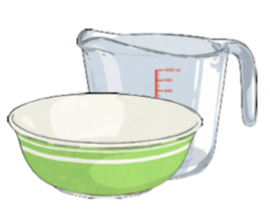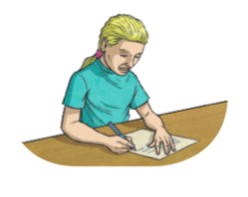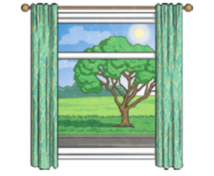

**Investigate Capacity**

Get a collection of containers, such as cups, saucepans, egg cups and bowls. Estimate how many smaller containers

it takes to fill a larger one, e.g. how many egg cups of water it takes to fill a saucepan. Try it out and see if your

estimate was close.

**Get Creative with Words**

Write a poem, song or rap about something you enjoy. Perhaps, you could change the words to a popular song or write an acrostic poem about your pet.

**Become a Landscape Artist**

Look out of a window and draw what you can see. Draw the same view at different times of the day. What changes do you notice?

