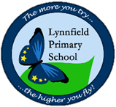
Year 6 – Home Learning Challenge 8
Hello Year 6, Hope you are all well! This week we are going back to Maths around your
home.
Remember your daily activities – to be reading for 15 minutes, learning your spellings and keeping fit and healthy. Could you create your own work out?
Be inventive.
Design and play your own Mathematical board game.
What age is your game aimed at?
What mathematical knowledge is needed?
Is your game visually appealing?
Have you created instructions?
You’re the teacher!
You have been learning all about decimals. Can you teach an adult how to multiply a decimal by a whole number?
Maths from your window..
Look outside with a Mathematical eye. What can you see?
Shapes? Symmetry? Parallel lines? Dimensions?
You will be amazed at how much Math surrounds us.
Count and Multiply
Count each of the following in your house: chairs, doors, cupboards, windows, pillows, clocks, spoons and shoes.
Before you begin counting, which calculation do you think will have the largest total?
chairs x doors
clocks x shoes
pillows x spoons
windows x cupboards
Paper aeroplanes.
Design and create three paper aeroplanes. This can be done with who you live with.
Record the distance each plane flies and see which one flies the furthest.
Plane 1 =
Plane 2 =
Plane 3 =
What was the difference in cm?
Prime Number hunt
How many prime numbers are written around your house?
What is the largest prime number you can find?
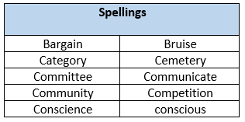
Weekly fun task
This week, be the reason someone smiles.
What kind gesture could you do for a family member? A friend? A neighbour?
A smile is contagious

