**Reception – Home learning challenge 9**

These challenges will also be uploaded to Tapestry where you can easily click on the links. <https://tapestryjournal.com/>

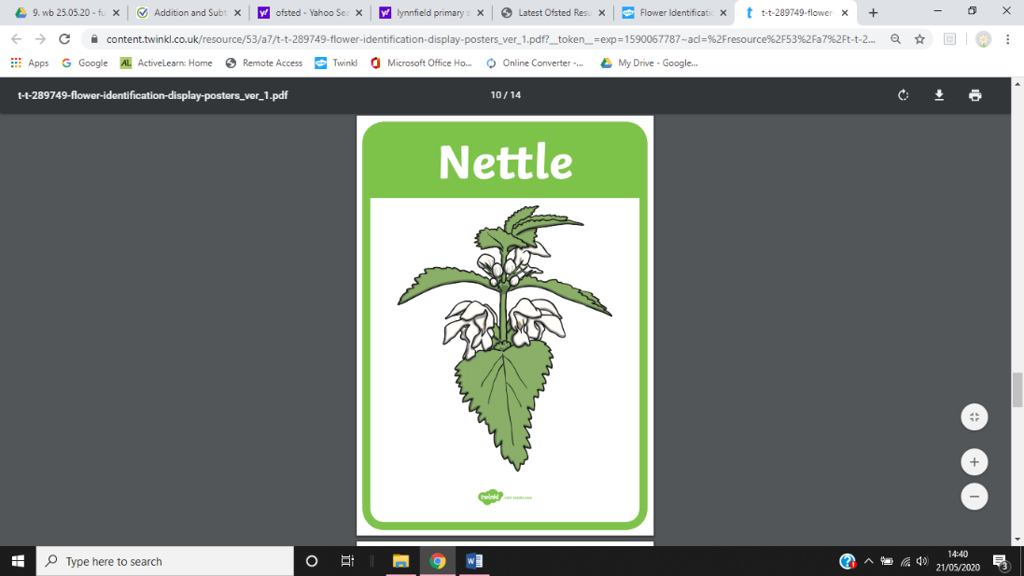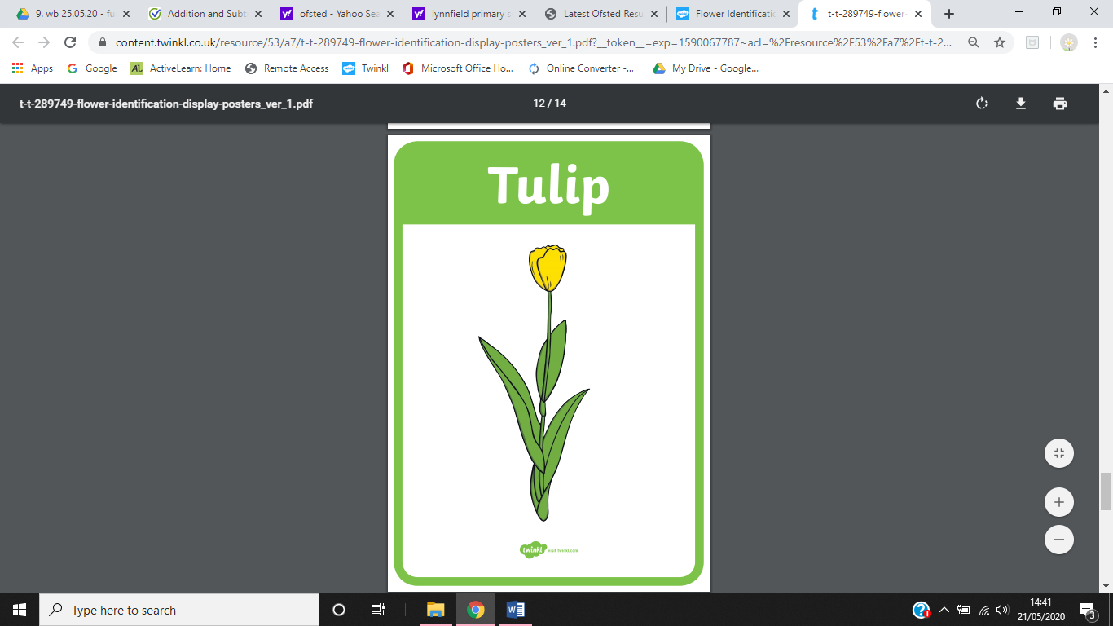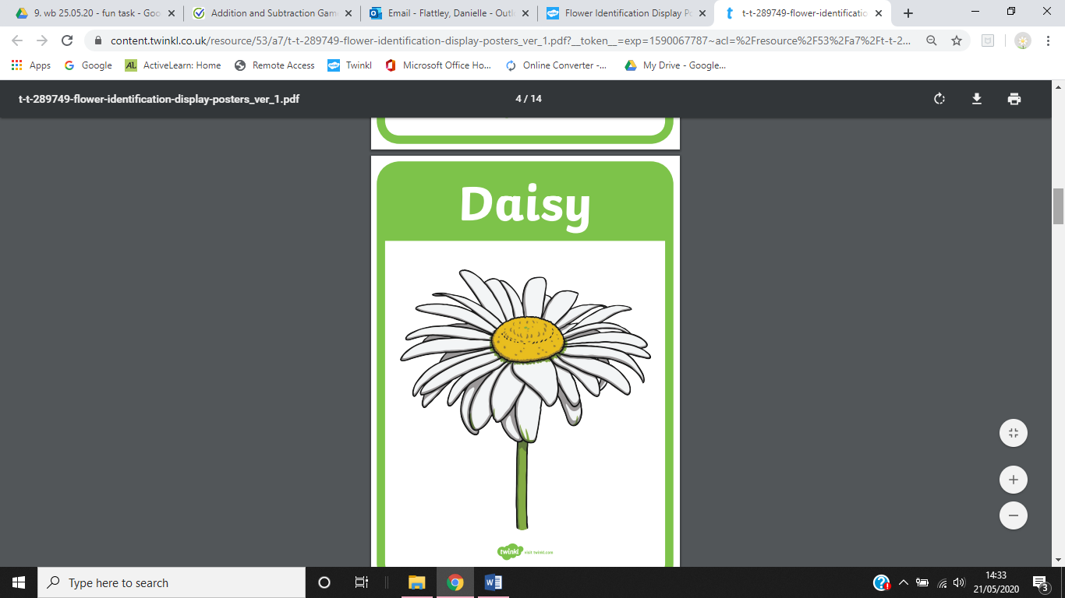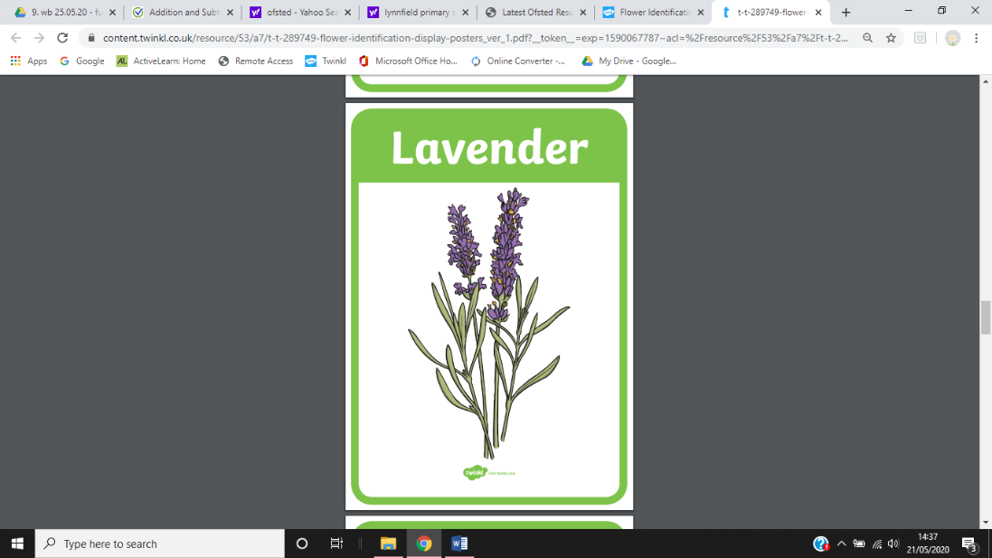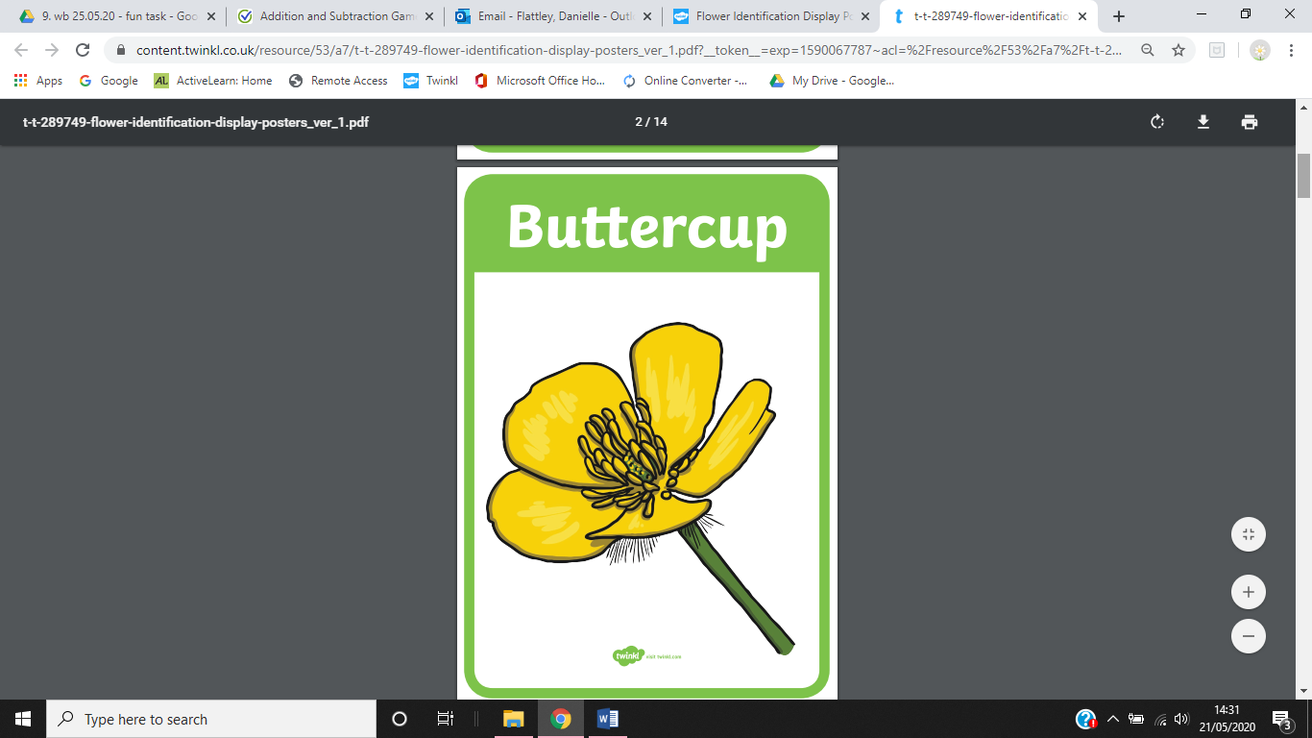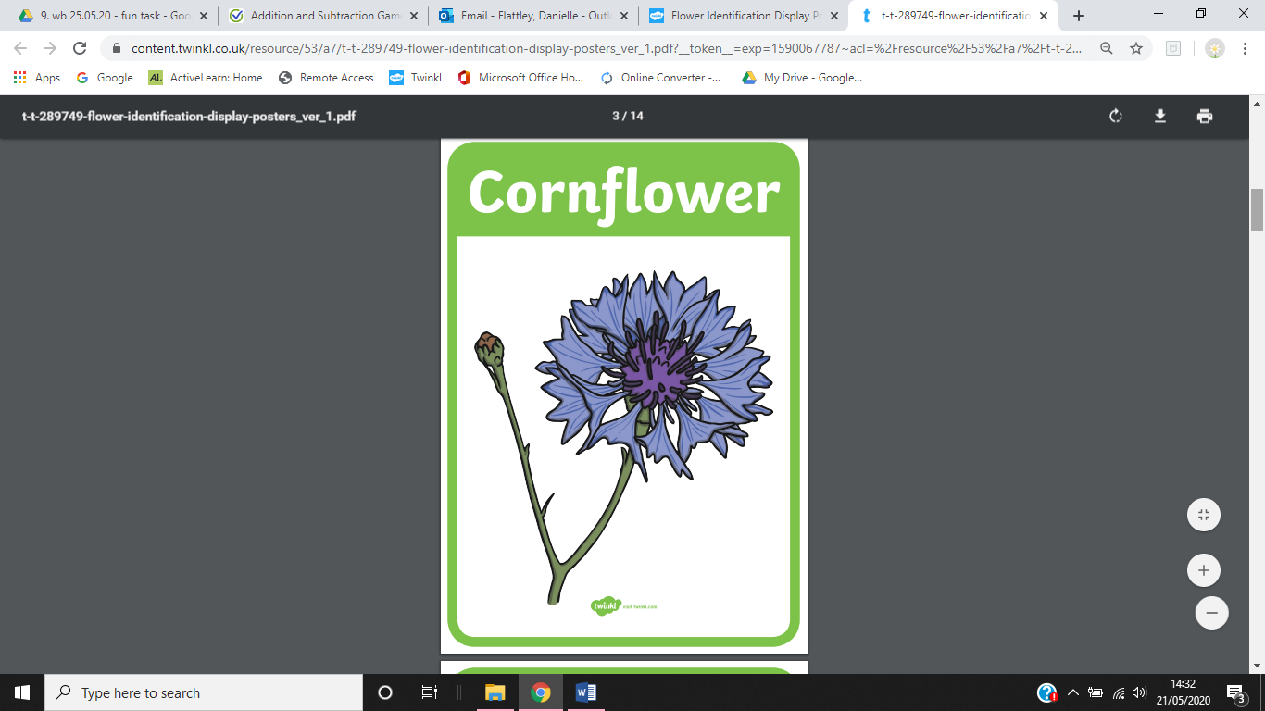

**Leaf Necklace**

**You will need:**

A selection of leaves

String

Small stick

Scissors

Hole punch (optional)

**The Activity**

1. Cut a length of string long enough for a necklace. Tie a small stick to one end of the string – this will act as a needle. Tie a large knot on the other end.

2. Allow a child to choose leaves for their necklace.

3. You may wish to make threading holes with the hole punch or you may wish for the children to make the holes themselves, either using the hole punch or a thin, firm stick.

4. Once the leaves have been threaded, cut off or untie the stick and tie the necklace into a loop.

5. Allow the children to wear their creations.

**Go for a walk**

Go for a walk with an adult from your home. Can you find any of these flowers?

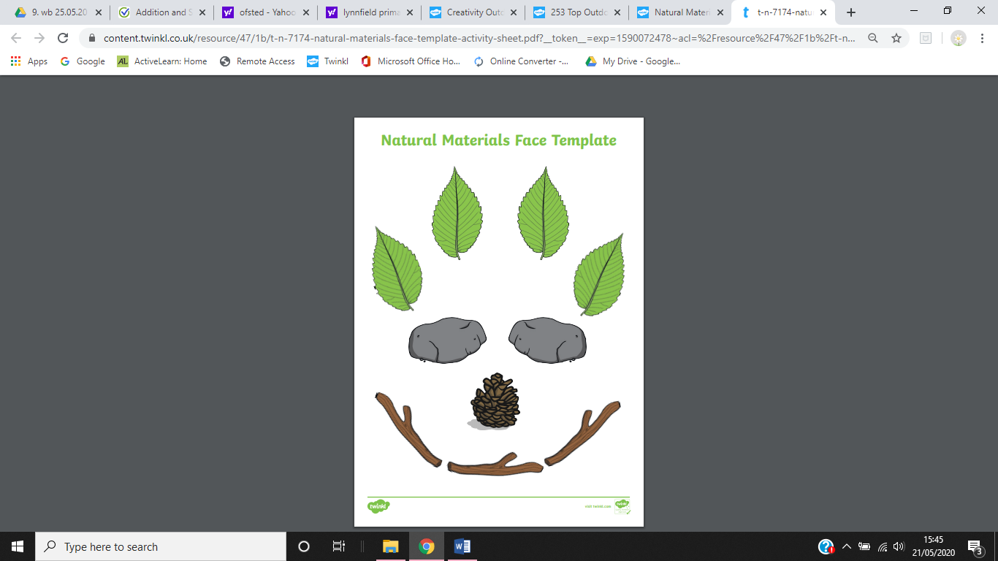

**Make a face!**

Find and gather resources on your walk. How many different faces can you make?

