**Year 1 – Home learning challenge 9**



Hello everyone!

Mrs Larkin and Miss Newby here!

We hope you and your families are keeping well and staying safe. Seeing as you have been working so hard with the tasks we have been giving you, we have chosen some fun tasks for you to do this week! We hope that the sun will continue to shine!

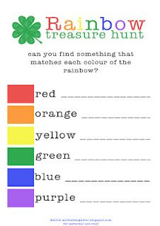

Have a go at making some of these delicious and fun picnic foods! Yum, Yum!

You could make your food look like brilliant bugs and marvellous minibeasts!

Why not have a picnic outside?





