**Year 4 – Home learning challenge 9**

**Daily activities**

Weekly fun task

Complete a nature diary

* Look outside each day and record what you see. Use tally charts and bar graphs to record this.
* Does this change over the week?
* Do you get different animals near your house at different times of the day? What about insects?
* Perhaps you might be able to take photographs of the animals you see.
* You could research these animals further and create a fact file. Remember you need a title and headings for an information text. What are their habitats? What do they like to eat?

Once you have made your birdfeeder have a look at the RSPB website and join in the Big Garden Bird Watch <https://www.rspb.org.uk/get-involved/activities/birdwatch/birds-to-look-out-for/> Take a note of the birds that visit your garden. Do you see any that are familiar like blackbirds, blue tits or even a robin?! Perhaps, you could research the birds that visit your garden. What might they like to eat? 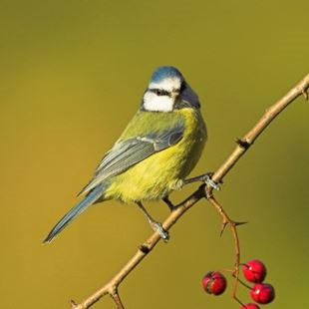

Spend some time outside (either in your garden or a nearby park) and listen to the sound of nature. What can you hear? Alternatively, listen to different sounds on YouTube: you might find it interesting to listen to relaxing sounds of the sea or bird song such as this: <https://www.youtube.com/watch?v=5lCRsLjMeso>

<https://www.youtube.com/watch?v=qtZZAMOYG-s> You could also try making your own bird feeder for some of the animals that you might observe while writing your nature diary. 