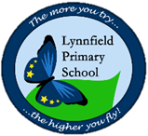
Year 6 – Home Learning Challenge 9
Well done to all children who are accessing their active learn account.
We are monitoring weekly who is completing their activities. This week, we would like you to take a break and engage in fun activities. We are expecting more glorious sunshine the next week so take full advantage.
Create your own ICE LOLLY.
Do you have any ice cube moulds? Ice lolly moulds?
What fruit flavoured juice could you us? Could you add real fruit?

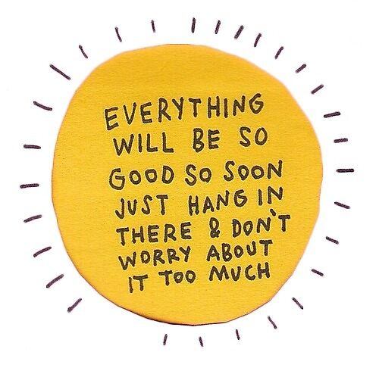
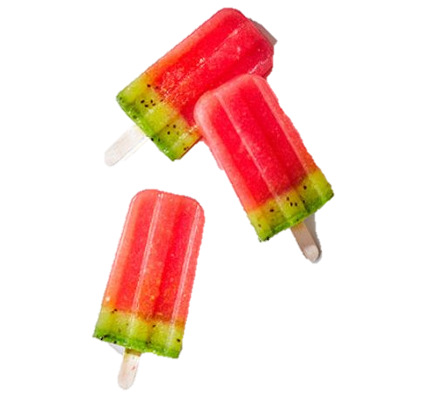
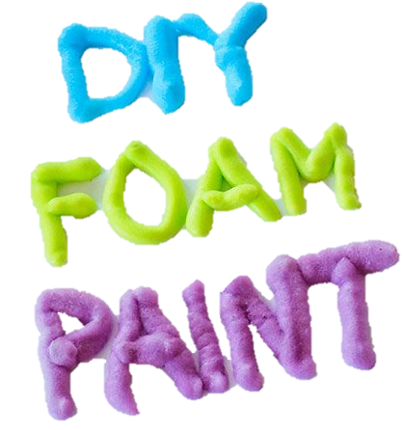
WATER ASSAULT COURSE
The year six team love nothing more than getting outside and having fun!
Next week, we are expecting a heat wave!
Gather all containers within your home. Could you create your own water assault course within an open space? Who can complete the course in the quickest time? Who can get soaked at the end?
Remember to wear your sun screen, sunglasses and drink lots of water!
You will need:
Shaving foam
Glue
Food colouring
Mix equal parts and seal a bag, squish the bag together until all ingredients are nicely mixed together. Voila!

