Year 1 – Home learning challenge 16
- Reading (20 mins) – choose a book to read that you love to read. How many rhyming words can you find?
- Spelling (15 mins) – choose 2 different words a day and write them in a sentence. Try to be creative! CHALLENGE! From the spellings you have been practising in the past few weeks, how many can you remember?
- Maths (15 mins) – complete a task from the fluency ladder – only move onto the next step when you are an expert! Ask people in your house to test you on a Friday (and maybe you could test them too!). Also, keep practicing your 2, 5 and 10 times tables on TTRockstars.
- FOCUS – Direction – using the vocabulary – up, down, left, right, half/quarter turn, forwards, backwards, make a treasure map and give directions to the treasure. Ask your mam or dad to see if they can find the treasure! You could even do one outside!
- Mindfulness – find a calm, quiet space and listen to some relaxing music. Lay down and imagine you are in a relaxing place. Or, you could do some mindfulness colouring sheets!
- Physical activity – Bounce! Dance! Skip! Why not make up a fitness routine for you and your family that include bouncing, dancing and skipping! Make sure your family join in too!
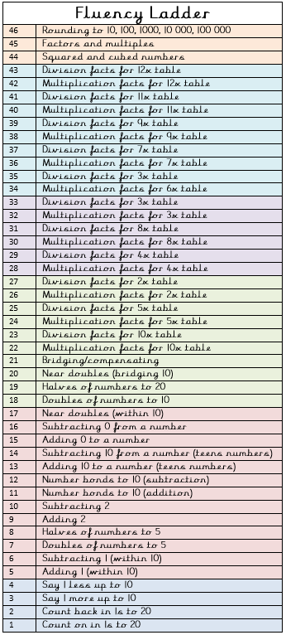
Spellings for the week
very | snappy
happy | hairy
funny | fairy
party | runny
family | merry
Weekly fun task!

Everyone loves a good picnic! This month is National picnic month so why not create a fantastic and delicious picnic that you and your family can share.

Draw a picture and write about what you did and ate on your family picnic.
You might like to do one of these activities on your picnic:
- Play a fun game
- Take your favourite teddy with you
- Invent a new tasty sandwich!

National Picnic Month

