Year 2 – Home Learning Challenge 16

Daily activities
- Reading (20 mins) – read a book you enjoy.
- Spelling (15 mins) – practise then choose 2 of the words from the box below and write them in a sentence.
- Maths (15 mins) – a task from the fluency ladder – only move onto the next step when you are an expert! Ask people in your house to test you on a Friday (maybe you could test them too!). Also keep practicing your 2, 5, 10- and 3-times tables on TTRockstars.
- Mindfulness – Gratitude practice: Keeping a
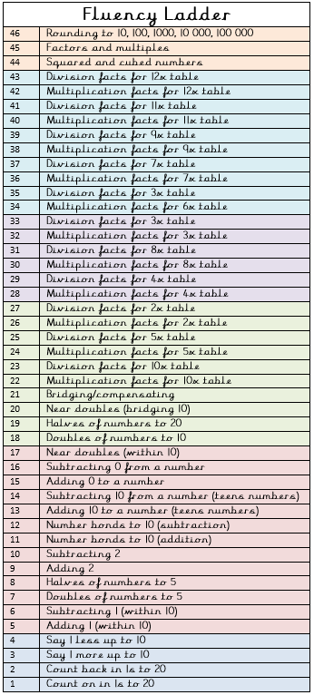
gratitude journal is one of the most well-established
happiness practices and the easiest to do.
Practising gratitude is central to the journal and
a simple introduction to the concept encourages
children to reflect on three positives of their day.
Research has shown that practising gratitude
through a journal increases a sense of happiness as
well as a range of physical, psychological, and social
benefits. Practising gratitude not only helps children
see the goodness in their lives but also that this can
come from a number of sources.
- Physical activity – Play waterbomb dodge ball,
just as much fun for the grown-ups as it is for the
children!!
Spellings for the week - HFW
floor | improve
gold | last
grass | many
half | money
hold | most
hour | parents

Weekly fun tasks
