Year 3 – Home learning challenge 16
Daily activities
- Reading Bug Club on activelearnprimary.co.uk and answer the quizzes or Oxford Owl RWI https://www.oxfordowl.co.uk/
- Spelling and Grammar (15 mins) practice using Look, Say, Cover, Write and Check – Test yourself on Friday. Try the activities allocated on activelearnprimary.co.uk
- Maths (15 mins) – a task from the fluency ladder – only move onto the next step when you are an expert! Test yourself on Friday. Also try https://ttrockstars.com/
- Mindfulness (10 mins) – Try https://www.youtube.com/user/CosmicKidsYoga
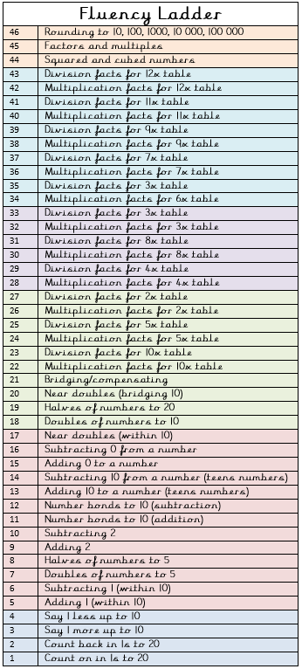
- Physical activity – Listen to a piece of upbeat music every day, turn up the volume and dance like no-one is watching! Or try Joe Wick’s workout and Oti Mabuse’s dance class .
Spellings
carefully | comically
completely | cuddly
gently | giggly
merrily | politely
humbly  Weekly fun task –  July is National Picnic Month.  Who doesn’t love a good picnic?  Create a delicious picnic that you and your family can share together. Perhaps you could even bake cakes!  - You can have your picnic at home – build a den to picnic in  - You can have your picnic in the garden  - You can visit a lovely quiet place and have a picnic too – providing you’re socially distanced of course! | suddenly

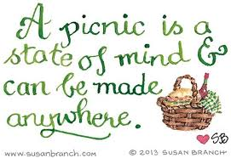
Don’t forget to send a photo to our Facebook page.

