**Year 5 – Home Learning Challenge 16**

**Daily activities**

|  |  |
| --- | --- |
| Spellings | |
| Discuss | Possess |
| Permit | Admit |
| Confess | Transmit |
| Depress | Progress |
| Submit | Impress |

* **Reading** Log onto your active learn and discover the many books and grammar activities we have set for you. We are checking regularly to see if more work is required!
* **Spelling (15 mins)**  Find the definition of any of the words you are unsure of. After that, write 9 sentences using these spelling rules.
* **Mindfulness (10 mins) –** Have a go at Cosmic yoga on Youtube.

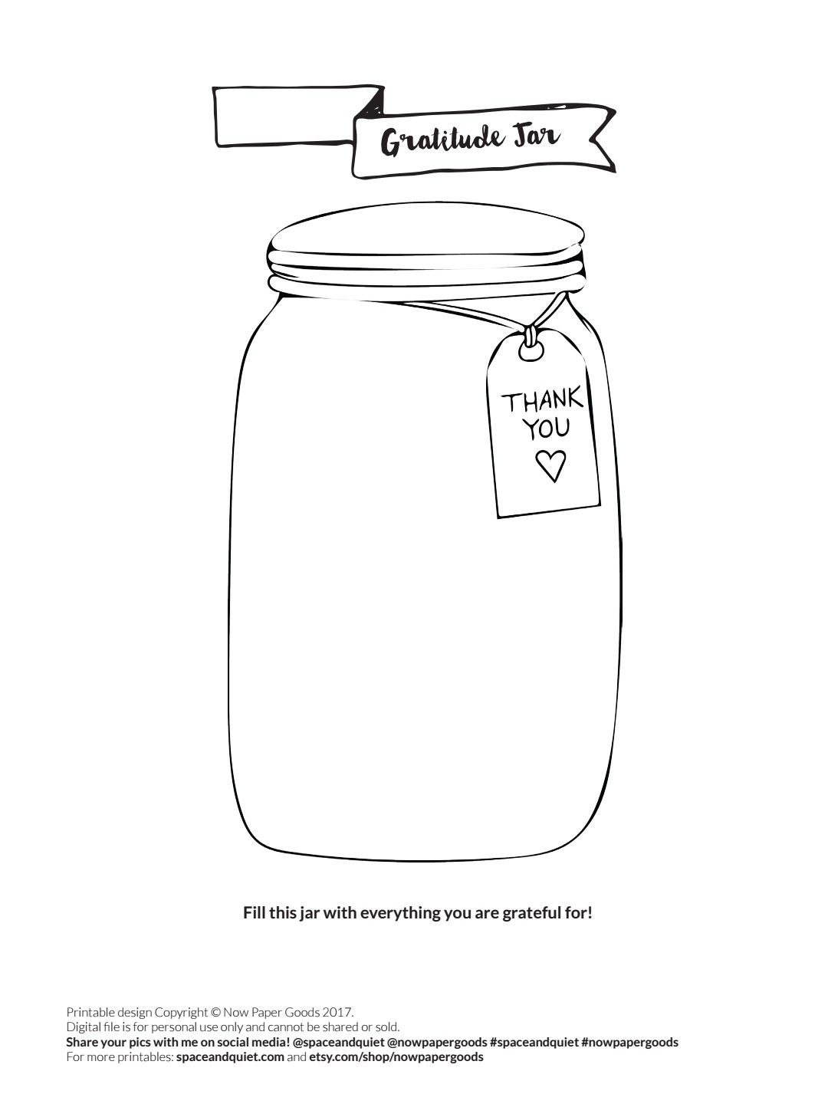

The last few months have been very difficult for a lot of us, so it is important to reflect and think about the things we are grateful for.

Use an old jar from your house and fill it with things you are thankful for.

It could be that you are grateful to wake up to beautiful weather, that you’ve spoken to your friends on the phone or that you have spent more time with your loved ones.

Continue to add to your jar throughout the upcoming weeks, month or year! You can open your jar at any point to be reminded of the things that have made your day a little brighter.

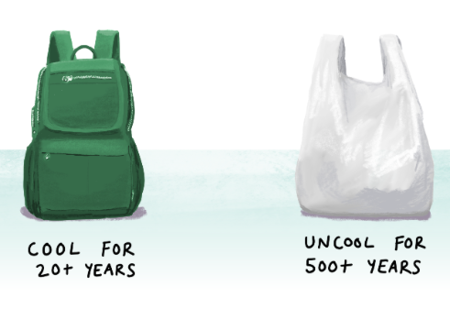

Think about the most heavily packaged items in your supermarket.

Do you think all of this packaging is needed?

Could you write a letter to your local supermarket to ask about their use of plastic packaging?

Plastics are amazing materials, often designed to be hard and long lasting. Some plastics are unsuitable for reusing with food or drink but can be used for other purposes.

Can you come up with some creative uses for plastic bags or bottles?

Can you create a poster to promote International Plastic Bag Free day?

You will need to use the internet to gather more information about the day to ensure your poster is factual.

Create a list of all the plastic items you use on a day to day basis.

Are any of these plastics single use?

Could you use an alternative that is better for the environment?

3rd International Plastic bag free day