Year 6 – Home Learning Challenge 16

Year 6, this will be your final home learning challenge. Thank you to parents/carers, family and friends who have supported the children within their challenges, it is much appreciated. Over the next six weeks, as you prepare for secondary school, we would ask that you create a diary of your thoughts. It is a big, but very exciting step. It is important to realise that lots of us will feel different emotions, and it is okay to experience happiness, nervousness, sadness…
Remember to look after yourself – physically and mentally over the next six weeks.
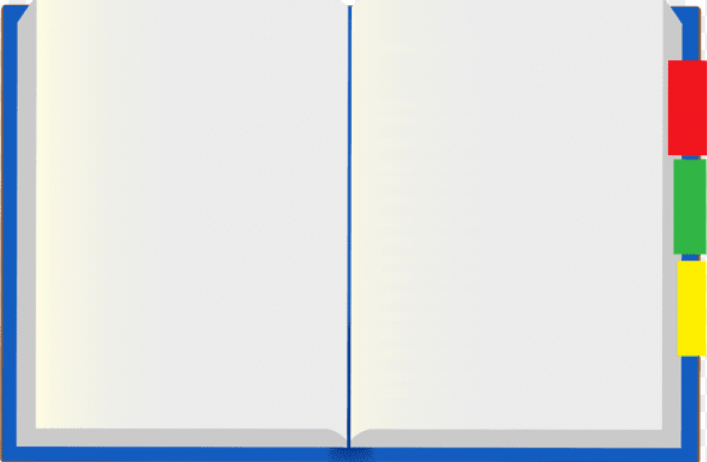
As I transition to secondary school…
What I would like people to know about me…
_______________________________________________________________________________________________________________
What are my skills? What makes me special? What talents do I have?
_______________________________________________________________________________________________________________

I hope to achieve..
__________________________________________________________________
What I fear most it….
__________________________________________________________________
I prepare myself by….
____________________________________________________________________

We would like to say a HUGE thank you for being an amazing cohort. You have made us all so proud.
May you continue to be the best you can be… the more you try, the higher you fly.
The Year 6 team

